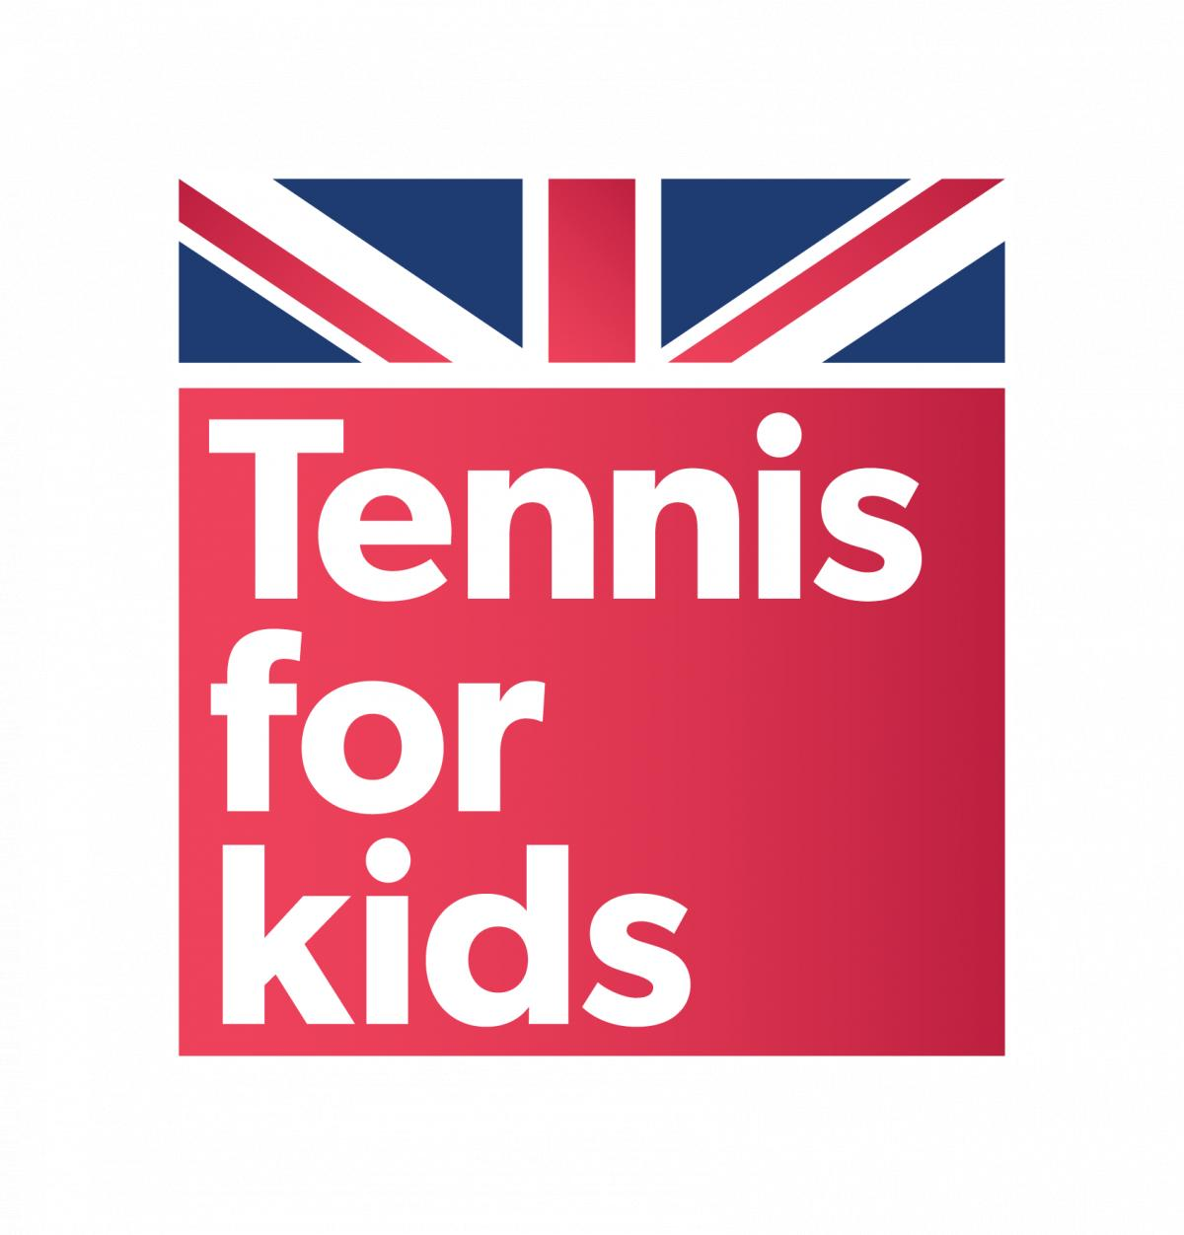

Press Release

Tuesday 10th July, 2018

**LAWN TENNIS ASSOCIATION ANNOUNCE 1,000 FURTHER TENNIS FOR KIDS PLACES IN LONDON**

More children than ever across London and the surrounding areas are getting the chance to take part in the Lawn Tennis Association’s (LTA) hugely successful Tennis for Kids programme and pick up a tennis racket for the first time, thanks to an increase in the number of places available for children in London and the South East.

The news, which comes during the Wimbledon fortnight, will around 1,000 more places made available for children across the city on the six session introductory tennis programmes, which are delivered by specially trained and accredited LTA coaches.

Tennis for Kids launched following Great Britain’s famous Davis Cup by BNP Paribas win in 2015. The programme is now is its third year and is aimed at children who have never played before to establish a genuine tennis participation legacy and develop a new generation of tennis loving children across the country.

Around 2,000 children are already taking part in courses across London with the increase in courses and places following an overwhelming demand from children to play, with over 150% continuing to play on a follow-on course. This forms part of the LTA’s plans to further grow the number of young players across the nation and meet rising demand for the programme, with some key changes this year including; being an ‘always on’ programme, widening the age range to four – 11 year olds and broadening the locations with even more accredited coaches taking part than ever before.

To celebrate this announcement, representatives from the LTA joined Tennis for Kids coaches and 30 local children at Stratford Park in Newham today (Tuesday) where the programme is already proving popular and made more accessible thanks to recent investment in park facilities by the LTA and the London Borough of Newham. Around 70 children are involved in the programme this year with another 100 places now available locally. With demand continuing to increase, LTA accredited coaches are now uploading further Tennis for Kids courses, enabling even more children to get on court.

Over 55,000 children across the country have taken part since Tennis for Kids’ inception in 2016 and there has been an unprecedented take up for this year’s programme, with over 21,000 sign ups so far this year.

**Tom Gibbins, Head of Children, Young People and Education at the LTA** said: “Tennis for Kids is proving to be very popular across the country and it’s brilliant that over 55,000 children have signed up to take part since it started. We are committed to enabling more children to try tennis and with the programme now available all year-round, we hope even more will have the chance to play. Being in Newham today has shown the fun and enthusiasm children have for the sport and it’s great to see Tennis for Kids thriving in all areas of London.”

The courses are aimed at children who have never played before, so focuses on fun and getting kids active, combining basic hand eye co-ordination with rudimentary tennis skills. Beyond the practical side of the sport, the sessions will be teaching children how to work with a partner, become a valuable member of a team - all in a fun and relaxed environment. Parents are also encouraged to join in for the final session which has a ‘Family Time’ theme.

**Nina Graveson-Bridge, London Community Business Manager at the LTA** also commented:

“The number of children signed up to Tennis for Kids sessions in London shows how the popularity of tennis is growing amongst young people in London. The redevelopment of facilities in boroughs such as Newham has created greater opportunities for kids to get active and play tennis. An increase in the number of courses and places available means children in the city and surrounding areas can be active all-year-round.”

The value for money 2courses take place all year-round across the country and also include their own kit with a special Tennis for Kids babolat racket, ball set and personalised t-shirt all delivered directly to them for £25.

**Chris Evans, a Tennis for Kids Coach in Newham** said:

“It’s been brilliant to be part of so many children’s first experience of tennis. The regeneration of facilities in Newham has had such a positive impact on children in the area and it’s vital that we, as coaches, continue to provide opportunities for young players by putting on more Tennis for Kids courses.”

To find out more and get involved with the Tennis for Kids programme, please visit [www.tennis-for-kids.co.uk](http://www.tennis-for-kids.co.uk) to sign up today.

**- ENDS -**

**1** Figures based on 2017 results of children partaking in a Tennis for Kids session

2Sessions around the country are coach and venue dependent and spaces are limited

**FOR MEDIA ENQUIRIES PLEASE CONTACT:** [Hannah.Waldegrave@lta.org.uk](mailto:Hannah.Waldegrave@lta.org.uk)

***ABOUT THE LTA***

The Lawn Tennis Association (LTA) is the National Governing Body for tennis in Great Britain, responsible for developing and promoting the sport, with a mission to get more people playing tennis more often.   It does this under the consumer brand of British Tennis, by working with a broad range of partners and over 25,000 volunteers, to grow the game in communities, clubs and schools.  The LTA represents the interests of over 590,000 British Tennis Members, men and women, girls and boys across the country, playing on more than 23,000 courts.  The LTA runs and supports a network of 11,500 approved tournaments for players of all ages, the corner-stones of which are the premier grass court events leading up to Wimbledon: the Nature Valley Open at Nottingham, the Nature Valley Classic at Birmingham, the Fever-Tree Championships at The Queen’s Club and the Nature Valley International at Eastbourne.  The LTA works with many delivery partners to grow the sport across the country.  One of these is its charitable entity, the Tennis Foundation, to provide a tennis provision for more than 20,000 schools, disadvantaged youth as well as promoting tennis as an inclusive sport for anyone with a disability.   For further information about the LTA and British Tennis, and to review the British Tennis strategy for 2015 – 2019 visit [www.lta.org.uk](http://www.lta.org.uk) or follow us on Twitter @BritishTennis