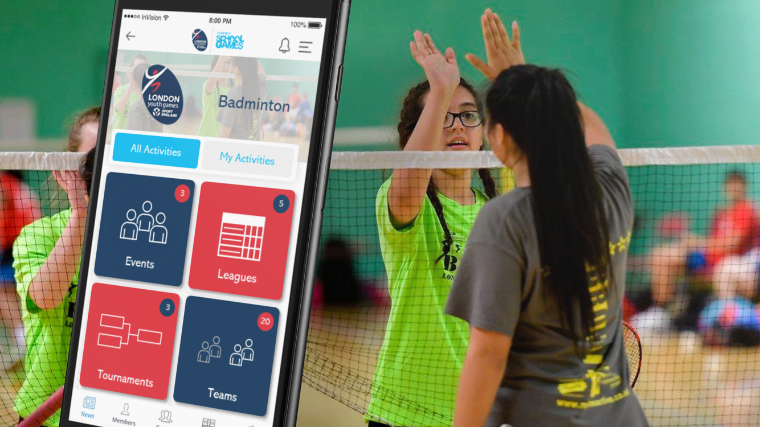

London Sport and London Youth Games choose Playwaze to deliver a new youth sports competition and event management platform in the capital

London Sport have commissioned sports activity and competition management platform
provider Playwaze to deliver a new web portal and mobile app to enable London Youth Games to improve the management and participant experience of youth sports competitions and events across London and its boroughs.

The London Youth Games is Europe's largest youth sports festival. The programme comprises of 47 annual events days across 30 different sports, giving young people from across all 33 London Boroughs the opportunity to represent their school or borough in their chosen sport. The Games include both School and Community Competitions and are very proud to be part of the National School Games programme funded by Sport England.

London Youth Games joined forces with British Universities & Colleges Sport (BUCS) in 2017, with investment from London Sport and a detailed market review and rigorous selection process leading to the decision to commission Playwaze to provide the Games’ next generation youth sports competition and activity management solution.

The decision to partner with Playwaze was based on their detailed understanding of youth sport requirements, their technology being purpose-built for sport through an intuitive mobile app, and the ability for Playwaze to build on their existing safeguarding capabilities to enable parents to manage their dependents’ participation in teams and competitions.

Commenting on the partnership, Jon Hughes, CEO of London Youth Games said:

“The London Youth Games Foundation exists in order to give young Londoners from all communities and boroughs the opportunity to come together to find out just what they are capable of through taking part in high quality sports competitions and volunteering programmes. We, with the support of London Sport and in partnership with BUCS, are confident that the Playwaze platform will enable us to provide our participants with a richer and more immersive experience, while also giving us communications and analysis options we have not had before, to help us understand and connect with young people in London. We are very excited by the potential.”

London Sport’s investment comes as part of a commitment to enhance the role of technology and data in supporting ambitions to make London the most physically active city in the world. The new London Youth Games platform is expected to enhance both the management of events and competitions, and the level of data available to agencies focused on physical activity and sport in London.

Tim Copley, Director of Insight and Performance for London Sport said:

“We are pleased to be able to support London Youth Games and Boroughs across the capital through our investment in this new platform. London Sport believes that good technology innovation will be a vital component in the future of physical activity and sport in the capital. By investing in this new partnership between Playwaze and London Youth Games, we will be supporting both the management of London Youth Games competitions, and growing our understanding of what works in getting young people across the capital to engage in physical activity and sport.”

Playwaze is a web and mobile sports activity and competition management platform. The ‘off-the-shelf’ Playwaze mobile app simplifies the way grassroots sport, physical activity and competitions get organised, while enhancing the participant’s engagement experience. This includes features for delivering group activities, courses, and sessions, running tournaments, leagues, ladders and leaderboards, ​managing teams, and tracking participant progression and development, with integral communication and payments features built-in.

The platform is also harnessed by organisations for the implementation of cost-effective, scalable web and mobile solutions. These can range from competition and activity management, workforce management and volunteer retention and open data solutions, web and mobile activity finders, ranking and participation reward systems, goal-setting and participant development trackers, and participation data capture, analytics and reporting solutions, with safeguarding features built-in for youth and disability sport.

Rupert Jenner, CEO of Playwaze has said:

“Playwaze is passionate about leveraging technology to simplify the way sport gets organised and transform the way we engage and attract both new and existing participants. We are delighted that our new partners, London Sport and London Youth Games, share in our vision and believe in Playwaze’s ability to deliver real benefits to youth sport in the capital. It is a fantastic opportunity for all parties to showcase the capabilities, efficiencies and benefits to all stakeholders and end users of a modern, mobile sports solution.”

London Sport, London Youth Games and Playwaze have also joined forces with British Universities & Colleges Sport (BUCS) to deliver a web and mobile competition management solution for intervarsity sport in the UK. BUCS, who are the governing body for Higher Education Sport in the UK, run programmes for over 50 sports for some 170 member institutions. This comprehensive programme sees over 6,000 teams compete in 900 leagues, alongside 140 individual sports events each year.

If you would like to find out more, please contact Charlie Clarke from Playwaze on +44 (0) 7850 445800 or charlieclarke@playwaze.com

